|  |
| --- |
| Experiment No. 8 |
| Implement Restoring algorithm using c-programming |
| Name: Dnyanesh Baburao Panchal |
| Roll Number: 34 |
| Date of Performance: |
| Date of Submission: |

**Aim:** To implement Restoring division algorithm using c-programming.

**Objective -**

1. To understand the working of Restoring division algorithm.
2. To understand how to implement Restoring division algorithm using c-programming.

**Theory:**

1) The divisor is placed in M register, the dividend placed in Q register.

2) At every step, the A and Q registers together are shifted to the left by 1-bit

3) M is subtracted from A to determine whether A divides the partial remainder. If it does, then Q0 set to 1-bit. Otherwise, Q0 gets a 0 bit and M must be added back to A to restore the previous value.

4) The count is then decremented and the process continues for n steps. At the end, the quotient is in the Q register and the remainder is in the A register.

**Flowchart**

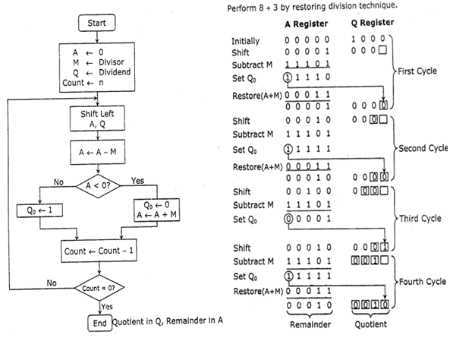

**Program-**

**#include <stdio.h>**

**#include <stdlib.h>**

**int dec_bin(int, int []);**

**int twos(int [], int []);**

**int left(int [], int []);**

**int add(int [], int []);**

**int main()**

**{**

**int a, b, m[4]={0,0,0,0}, q[4]={0,0,0,0}, acc[4]={0,0,0,0}, m2[4], i, n=4;**

**printf("Enter the Dividend: ");**

**scanf("%d", &a);**

**printf("Enter the Divisor: ");**

**scanf("%d", &b);**

**dec_bin(a, q);**

**dec_bin(b, m);**

**twos(m, m2);**

**printf("\nA\tQ\tComments\n");**

**for(i=3; i>=0; i--)**

**{**

**printf("%d", acc[i]);**

**}**

**printf("\t");**

**for(i=3; i>=0; i--)**

**{**

**printf("%d", q[i]);**

**}**

**printf("\tStart\n");**

**while(n>0)**

**{**

**left(acc, q);**

**for(i=3; i>=0; i--)**

**{**

**printf("%d", acc[i]);**

**}**

**printf("\t");**

**for(i=3; i>=1; i--)**

**{**

**printf("%d", q[i]);**

**}**

**printf("_\tLeft Shift A,Q\n");**

**add(acc, m2);**

**for(i=3; i>=0; i--)**

**{**

**printf("%d", acc[i]);**

**}**

**printf("\t");**

**for(i=3; i>=1; i--)**

**{**

**printf("%d", q[i]);**

**}**

**printf("_\tA=A-M\n");**

**if(acc[3]==0)**

**{**

**q[0]=1;**

**for(i=3; i>=0; i--)**

**{**

**printf("%d", acc[i]);**

**}**

**printf("\t");**

**for(i=3; i>=0; i--)**

**{**

**printf("%d", q[i]);**

**}**

**printf("\tQo=1\n");**

**}**

**else**

**{**

**q[0]=0;**

**add(acc, m);**

**for(i=3; i>=0; i--)**

**{**

**printf("%d", acc[i]);**

**}**

**printf("\t");**

**for(i=3; i>=0; i--)**

**{**

**printf("%d", q[i]);**

**}**

**printf("\tQo=0; A=A+M\n");**

**}**

**n--;**

**}**

**printf("\nQuotient = ");**

**for(i=3; i>=0; i--)**

**{**

**printf("%d", q[i]);**

**}**

**printf("\tRemainder = ");**

**for(i=3; i>=0; i--)**

**{**

**printf("%d", acc[i]);**

**}**

**printf("\n");**

**return 0;**

**}**

**int dec_bin(int d, int m[])**

**{**

**int b=0, i=0;**

**for(i=0; i<4; i++)**

**{**

**m[i]=d%2;**

**d=d/2;**

**}**

**return 0;**

**}**

**int twos(int m[], int m2[])**

**{**

**int i, m1[4];**

**for(i=0; i<4; i++)**

**{**

**if(m[i]==0)**

**{**

**m1[i]=1;**

**}**

**else**

**{**

**m1[i]=0;**

**}**

**}**

**for(i=0; i<4; i++)**

**{**

**m2[i]=m1[i];**

**}**

**if(m2[0]==0)**

**{**

**m2[0]=1;**

**}**

**else**

**{**

**m2[0]=0;**

**if(m2[1]==0)**

**{**

**m2[1]=1;**

**}**

**else**

**{**

**m2[1]=0;**

**if(m2[2]==0)**

**{**

**m2[2]=1;**

**}**

**else**

**{**

**m2[2]=0;**

**if(m2[3]==0)**

**{**

**m2[3]=1;**

**}**

**else**

**{**

**m2[3]=0;**

**}**

**}**

**}**

**}**

**return 0;**

**}**

**int left(int acc[], int q[])**

**{**

**int i;**

**for(i=3; i>0; i--)**

**{**

**acc[i]=acc[i-1];**

**}**

**acc[0]=q[3];**

**for(i=3; i>0; i--)**

**{**

**q[i]=q[i-1];**

**}**

**}**

**int add(int acc[], int m[])**

**{**

**int i, carry=0;**

**for(i=0; i<4; i++)**

**{**

**if(acc[i]+m[i]+carry==0)**

**{**

**acc[i]=0;**

**carry=0;**

**}**

**else if(acc[i]+m[i]+carry==1)**

**{**

**acc[i]=1;**

**carry=0;**

**}**

**else if(acc[i]+m[i]+carry==2)**

**{**

**acc[i]=0;**

**carry=1;**

**}**

**else if(acc[i]+m[i]+carry==3)**

**{**

**acc[i]=1;**

**carry=1;**

**}**

**}**

**return 0;**

**}**

**Output -**

**Enter the Dividend: 12**

**Enter the Divisor: 2**

**A Q Comments**

**0000 1100 Start**

**0001 100_ Left Shift A,Q**

**1111 100_ A=A-M**

**0001 1000 Qo=0; A=A+M**

**0011 000_ Left Shift A,Q**

**0001 000_ A=A-M**

**0001 0001 Qo=1**

**0010 001_ Left Shift A,Q**

**0000 001_ A=A-M**

**0000 0011 Qo=1**

**0000 011_ Left Shift A,Q**

**1110 011_ A=A-M**

**0000 0110 Qo=0; A=A+M**

**Quotient = 0110 Remainder = 0000**

**Conclusion -**

This experiment involving the Restoring Division Algorithm has provided a comprehensive understanding of this fundamental technique for binary division. The algorithm's step-by-step restoration process allows for precise quotient calculation, making it a valuable tool in computer arithmetic. This experiment has not only reinforced the importance of understanding and implementing division algorithms but has also demonstrated its practical application in various computer systems and data processing tasks.